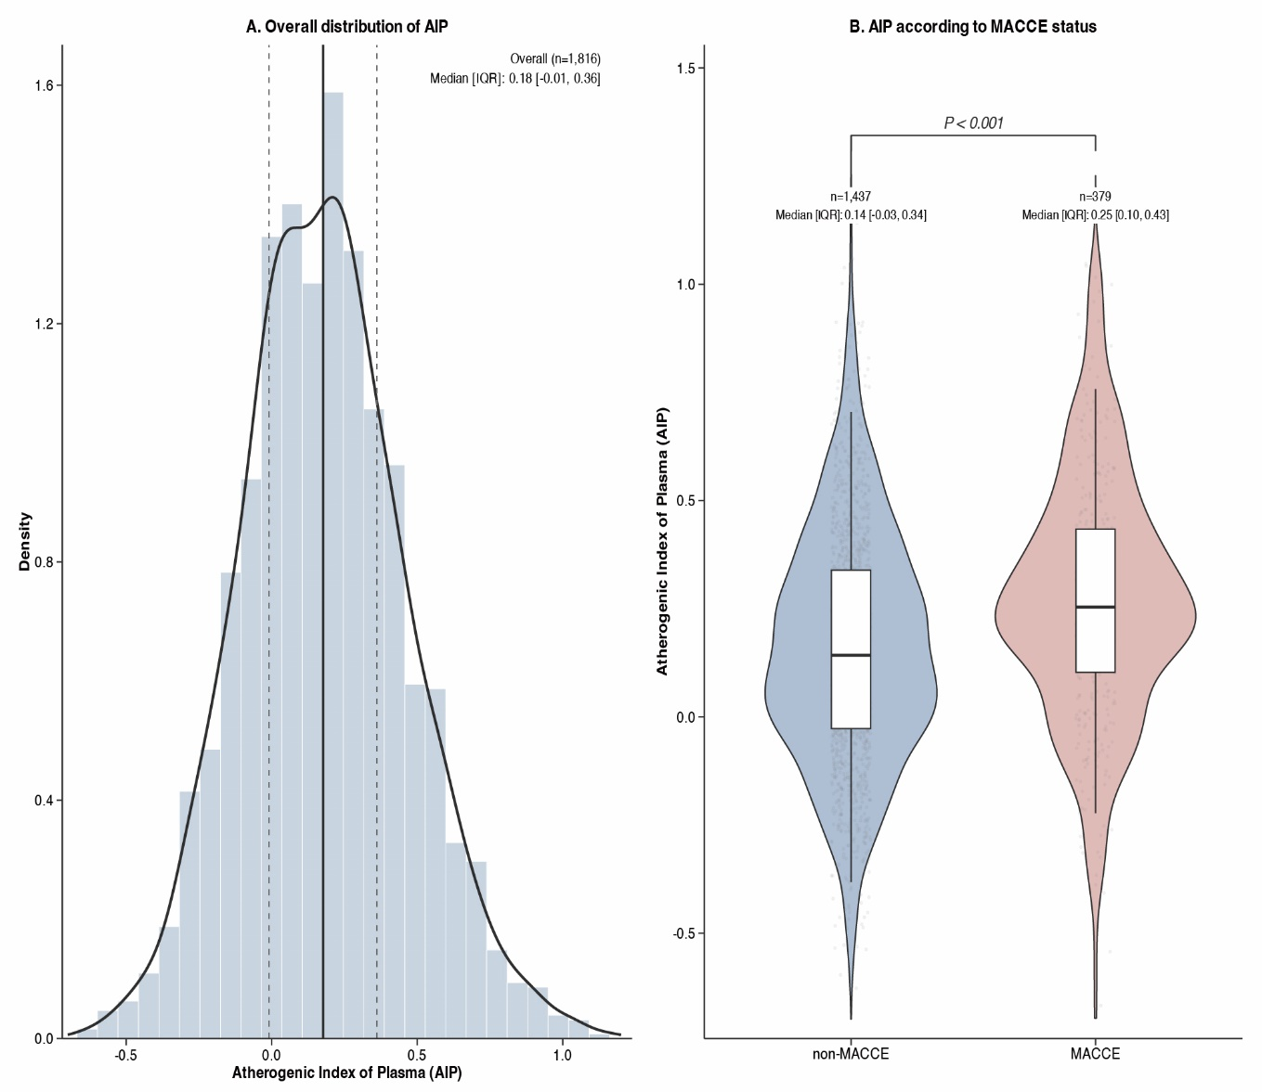
Supplementary Fig. 1. Distribution Characteristics of the Atherogenic Index of Plasma in the Study Population and by MACCE Status. MACCE, major adverse cardiac and cerebrovascular events.

Supplementary Table 1. Cox regression models for the associations between AIP and MACCE.
Characteristic | Univariable |  |  |  | Multivariate
Characteristic | N | HR | 95% CI | P value | HR | 95% CI | P value
Sex | 1,816 | 0.72 | 0.59, 0.89 | 0.002 | 0.76 | 0.59, 0.96 | 0.022
Age | 1,816 | 1.00 | 0.99, 1.01 | 0.4
Previous MI | 1,816 | 1.60 | 1.24, 2.05 | <0.001 | 1.36 | 1.04, 1.77 | 0.024
Previous AF | 1,816 | 1.31 | 0.92, 1.86 | 0.13
Hypertension | 1,816 | 1.56 | 1.12, 2.17 | 0.008 | 1.37 | 0.98, 1.92 | 0.066
Diabetes | 1,816 | 1.91 | 1.56, 2.34 | <0.001 | 1.53 | 1.17, 2.00 | 0.002
Hyperlipidemia | 1,816 | 1.10 | 0.83, 1.46 | 0.5
Stroke History | 1,816 | 1.23 | 0.97, 1.56 | 0.082
Peripheral arterial disease | 1,816 | 1.38 | 0.79, 2.39 | 0.3
CKD Stage | 1,816
G2 |  | — | — |  | — | —
G3 |  | 1.86 | 1.45, 2.38 | <0.001 | 1.22 | 0.73, 2.02 | 0.4
G4 |  | 2.57 | 1.80, 3.67 | <0.001 | 1.13 | 0.48, 2.63 | 0.8
G5 |  | 2.44 | 1.85, 3.20 | <0.001 | 1.43 | 0.50, 4.15 | 0.5
Anemia | 1,816 | 2.56 | 1.77, 3.70 | <0.001 | 1.27 | 0.84, 1.92 | 0.3
Smoking | 1,816 | 1.14 | 0.92, 1.41 | 0.2
Drinking | 1,816 | 0.87 | 0.67, 1.14 | 0.3
MI | 1,816 | 1.84 | 1.51, 2.26 | <0.001 | 1.39 | 1.09, 1.77 | 0.009
PCI | 1,816 | 1.23 | 0.97, 1.55 | 0.093
SBP | 1,816 | 1.00 | 1.00, 1.00 | 0.8
DBP | 1,816 | 1.00 | 0.99, 1.00 | 0.4
HR | 1,816 | 1.01 | 1.00, 1.01 | 0.014 | 1.00 | 0.99, 1.00 | 0.2
Hb | 1,816 | 0.99 | 0.98, 0.99 | <0.001 | 0.99 | 0.99, 1.00 | 0.006
PLT | 1,816 | 1.00 | 1.00, 1.00 | >0.9
Urea | 1,816 | 1.06 | 1.04, 1.07 | <0.001 | 1.00 | 0.98, 1.02 | >0.9
Scr | 1,816 | 1.00 | 1.00, 1.00 | 0.3
eGFR | 1,816 | 0.99 | 0.98, 0.99 | <0.001 | 1.00 | 0.98, 1.01 | 0.8
UA | 1,816 | 1.00 | 1.00, 1.00 | 0.026 | 1.00 | 1.00, 1.00 | 0.8
TC | 1,816 | 0.93 | 0.85, 1.02 | 0.12 | 1.45 | 0.83, 2.55 | 0.2
TG | 1,816 | 1.16 | 1.08, 1.25 | <0.001 | 0.82 | 0.64, 1.06 | 0.14
HDL-C | 1,816 | 0.19 | 0.12, 0.28 | <0.001 | 0.64 | 0.25, 1.67 | 0.4
LDL-C | 1,816 | 0.96 | 0.86, 1.07 | 0.4 | 0.63 | 0.33, 1.19 | 0.2
non-HDL-C | 1,816 | 1.02 | 0.93, 1.11 | 0.7
AIP | 1,816 | 3.49 | 2.47, 4.93 | <0.001 | 4.32 | 1.26, 14.8 | 0.020
FPG | 1,816 | 1.06 | 1.04, 1.08 | <0.001 | 1.03 | 1.01, 1.05 | 0.014
TnI | 1,816 | 1.01 | 1.00, 1.01 | 0.043 | 1.00 | 0.99, 1.01 | >0.9
CK-MB | 1,816 | 1.00 | 1.00, 1.00 | 0.3
NT-proBNP | 1,816 | 1.00 | 1.00, 1.00 | <0.001 | 1.00 | 1.00, 1.00 | 0.8
LVEF | 1,816 | 0.97 | 0.96, 0.98 | <0.001 | 0.99 | 0.97, 1.00 | 0.020
Antiplatelet drugs | 1,816 | 1.16 | 0.79, 1.69 | 0.4
Statin | 1,816 | 0.91 | 0.64, 1.29 | 0.6
Beta blocker | 1,816 | 1.35 | 1.09, 1.66 | 0.005 | 1.17 | 0.94, 1.46 | 0.15
ACEI or ARB | 1,816 | 0.58 | 0.45, 0.74 | <0.001 | 0.77 | 0.58, 1.01 | 0.058
Oral hypoglycemic agents | 1,816 | 1.30 | 1.04, 1.62 | 0.021 | 0.74 | 0.56, 0.99 | 0.039
CCB | 1,816 | 1.05 | 0.86, 1.29 | 0.6
Insulin therapy | 1,816 | 0.96 | 0.77, 1.20 | 0.7
Dialysis therapy | 1,816 | 2.18 | 1.25, 3.78 | 0.006 | 0.89 | 0.48, 1.66 | 0.7
HR, Hazard Ratio; CI, confidence interval; MACCE, major adverse cardiac and cerebrovascular events; MI, myocardial infarction; AF, atrial fibrillation; CKD, chronic kidney disease; ACS, acute coronary syndrome; PCI, percutaneous coronary intervention; SBP, systolic blood pressure; DBP, diastolic blood pressure; HR, heart rate; LVEF, left ventricular ejection fraction; Hb, hemoglobin; PLT, platelet; Urea, carbamide; Scr, serum creatinine; eGFR, estimated glomerular filtration rate; UA, uric acid; TC, total cholesterol; TG, triglycerides; HDL-C, high-density lipoprotein-cholesterol; LDL-C, low-density lipoprotein-cholesterol; FPG, fasting plasma glucose; TnI, troponin I; CK-MB, creatine kinase-MB; NT-proBNP, N-terminal pro-brain natriuretic peptide; AIP, atherogenic index of plasma; ACEI, angiotensin-converting enzyme inhibitors; ARB, angiotensin receptor blockers; CCB, calcium channel blocker.
Supplementary Table 2. Distribution of sample size and MACCE events according to combined CKD strata in the overall cohort
CKD subgroup | Total | MACCE | Non-MACCE
Stage 2–3 | 1,457 | 268 | 1,189
Stage 4–5 | 359 | 111 | 248
MACCE, major adverse cardiac and cerebrovascular events; CKD, chronic kidney disease.

Supplementary Table 3. Sensitivity analysis of the association between elevated AIP and MACCE in Stage 2–3 versus Stage 4–5 CKD in the overall cohort
CKD subgroup | N | Events | Adjusted HR (95% CI) | P value | P for interaction
Stage 2–3 CKD | 1,457 | 268 | 1.98 (1.47–2.66) | <0.001 | 0.149
Stage 4–5 CKD | 359 | 111 | 2.92 (1.68–5.08) | <0.001
HR, hazard ratio; CI, confidence interval; MACCE, major adverse cardiac and cerebrovascular events; CKD, chronic kidney disease.
Adjusted HRs were derived from multivariable Cox proportional hazards models controlling for sex, age, previous myocardial infarction, hypertension, diabetes mellitus, hyperlipidemia, stroke history, smoking, anemia, myocardial infarction type, PCI, systolic blood pressure, heart rate, hemoglobin, urea, uric acid, LDL-C, non-HDL-C, fasting plasma glucose, troponin I, NT-proBNP, left ventricular ejection fraction, antiplatelet therapy, statin use, beta-blocker use, ACEI/ARB use, oral hypoglycemic agents, and dialysis.

Supplementary Table 4. Ordinal interaction analysis treating CKD stage as an ordered variable in the overall cohort
Analysis | Interaction HR (95% CI) | P for interaction
Ordinal CKD-stage interaction in the overall cohort | 1.08 (0.87–1.34) | 0.481
HR, hazard ratio; CI, confidence interval; CKD, chronic kidney disease.

Supplementary Table 5. Repeated advanced CKD subgroup sensitivity analysis after excluding patients who experienced MACCE within 30 days
CKD subgroup | N | Events | Adjusted HR (95% CI) | P value | P for interaction
Stage 2–3 CKD | 1,417 | 228 | 1.46 (1.06–2.01) | 0.019 | 0.110
Stage 4–5 CKD | 339 | 91 | 2.53 (1.41–4.54) | 0.002
HR, hazard ratio; CI, confidence interval; MACCE, major adverse cardiac and cerebrovascular events; CKD, chronic kidney disease.
Adjusted HRs were derived from multivariable Cox proportional hazards models controlling for sex, age, previous myocardial infarction, hypertension, diabetes mellitus, hyperlipidemia, stroke history, smoking, anemia, myocardial infarction type, PCI, systolic blood pressure, heart rate, hemoglobin, urea, uric acid, LDL-C, non-HDL-C, fasting plasma glucose, troponin I, NT-proBNP, left ventricular ejection fraction, antiplatelet therapy, statin use, beta-blocker use, ACEI/ARB use, oral hypoglycemic agents, and dialysis.

Supplementary Table 6. Ordinal CKD-stage interaction analysis after excluding patients who experienced MACCE within 30 days
Analysis | Interaction HR (95% CI) | P for interaction
Ordinal CKD-stage interaction in the overall cohort | 1.11 (0.89–1.38) | 0.359
HR, hazard ratio; CI, confidence interval; MACCE, major adverse cardiac and cerebrovascular events; CKD, chronic kidney disease.
Supplementary Table 7. Cox regression models for the associations between AIP and MACCE (sensitivity analysis).
Characteristic | Univariable |  |  |  | Multivariate
Characteristic | N | HR | 95% CI | P value | HR | 95% CI | P value
Sex | 1,713 | 0.72 | 0.57, 0.90 | 0.004 | 0.68 | 0.51, 0.89 | 0.006
Age | 1,713 | 1.00 | 0.99, 1.01 | 0.7 | 1.02 | 1.01, 1.03 | 0.004
Previous MI | 1,713 | 1.77 | 1.36, 2.31 | <0.001 | 1.43 | 1.08, 1.91 | 0.013
Previous AF | 1,713 | 1.27 | 0.86, 1.87 | 0.2
Hypertension | 1,713 | 1.59 | 1.11, 2.29 | 0.011 | 1.39 | 0.96, 2.02 | 0.085
Diabetes | 1,713 | 2.05 | 1.64, 2.55 | <0.001 | 1.66 | 1.23, 2.22 | <0.001
Hyperlipidemia | 1,713 | 1.04 | 0.76, 1.42 | 0.8 | 1.05 | 0.76, 1.45 | 0.8
Stroke History | 1,713 | 1.35 | 1.05, 1.73 | 0.020 | 1.20 | 0.92, 1.56 | 0.2
Peripheral arterial disease | 1,713 | 1.15 | 0.59, 2.22 | 0.7
CKD Stage | 1,713
G2 |  | — | — |  | — | —
G3 |  | 1.94 | 1.49, 2.54 | <0.001 | 1.11 | 0.64, 1.91 | 0.7
G4 |  | 2.40 | 1.60, 3.61 | <0.001 | 0.90 | 0.36, 2.25 | 0.8
G5 |  | 2.56 | 1.90, 3.44 | <0.001 | 1.58 | 0.49, 5.08 | 0.4
Anemia | 1,713 | 2.53 | 1.66, 3.88 | <0.001 | 1.16 | 0.71, 1.89 | 0.5
Smoking | 1,713 | 1.09 | 0.86, 1.39 | 0.5 | 0.98 | 0.76, 1.28 | >0.9
Drinking | 1,713 | 0.95 | 0.71, 1.26 | 0.7
MI | 1,713 | 1.72 | 1.38, 2.14 | <0.001 | 1.40 | 1.07, 1.84 | 0.015
PCI | 1,713 | 1.49 | 1.14, 1.95 | 0.004 | 1.15 | 0.87, 1.53 | 0.3
SBP | 1,713 | 1.00 | 1.00, 1.01 | 0.6 | 1.00 | 0.99, 1.00 | 0.4
DBP | 1,713 | 1.00 | 0.99, 1.01 | 0.5
HR | 1,713 | 1.01 | 1.00, 1.01 | 0.10 | 1.00 | 0.99, 1.00 | 0.2
Hb | 1,713 | 0.99 | 0.98, 0.99 | <0.001 | 0.99 | 0.99, 1.00 | 0.058
PLT | 1,713 | 1.00 | 1.00, 1.00 | 0.7
Urea | 1,713 | 1.06 | 1.05, 1.08 | <0.001 | 1.01 | 0.99, 1.04 | 0.4
Scr | 1,713 | 1.00 | 1.00, 1.00 | 0.5 | 1.00 | 1.00, 1.00 | 0.2
eGFR | 1,713 | 0.99 | 0.98, 0.99 | <0.001 | 0.99 | 0.98, 1.01 | 0.4
UA | 1,713 | 1.00 | 1.00, 1.00 | 0.051 | 1.00 | 1.00, 1.00 | 0.8
TC | 1,713 | 0.91 | 0.82, 1.00 | 0.059
TG | 1,713 | 1.14 | 1.05, 1.23 | 0.002
HDL-C | 1,713 | 0.25 | 0.16, 0.40 | <0.001
LDL-C | 1,713 | 0.92 | 0.81, 1.03 | 0.2 | 0.73 | 0.42, 1.27 | 0.3
non-HDL-C | 1,713 | 0.98 | 0.89, 1.08 | 0.7 | 1.26 | 0.78, 2.03 | 0.3
AIP | 1,713 | 2.71 | 1.85, 3.96 | <0.001 | 1.98 | 1.16, 3.41 | 0.013
FPG | 1,713 | 1.07 | 1.04, 1.09 | <0.001 | 1.04 | 1.01, 1.07 | 0.005
TnI | 1,713 | 1.00 | 0.99, 1.01 | 0.9 | 0.99 | 0.98, 1.00 | 0.069
CK-MB | 1,713 | 1.00 | 1.00, 1.00 | 0.7
NT-proBNP | 1,713 | 1.00 | 1.00, 1.00 | <0.001 | 1.00 | 1.00, 1.00 | 0.6
LVEF | 1,713 | 0.97 | 0.96, 0.98 | <0.001 | 0.98 | 0.97, 1.00 | 0.020
Antiplatelet drugs | 1,713 | 1.12 | 0.75, 1.69 | 0.6 | 0.91 | 0.59, 1.38 | 0.6
Statin | 1,713 | 1.08 | 0.72, 1.63 | 0.7 | 1.25 | 0.82, 1.91 | 0.3
Beta blocker | 1,713 | 1.29 | 1.03, 1.62 | 0.027 | 1.17 | 0.92, 1.48 | 0.2
ACEI or ARB | 1,713 | 0.61 | 0.47, 0.80 | <0.001 | 0.83 | 0.62, 1.11 | 0.2
Oral hypoglycemic agents | 1,713 | 1.35 | 1.06, 1.72 | 0.014 | 0.71 | 0.52, 0.97 | 0.031
CCB | 1,713 | 1.07 | 0.86, 1.33 | 0.6
Insulin therapy | 1,713 | 0.82 | 0.64, 1.05 | 0.11
Dialysis therapy | 1,713 | 2.51 | 1.41, 4.47 | 0.002 | 0.87 | 0.44, 1.71 | 0.7
HR, hazard ratio; CI, confidence interval; MACCE, major adverse cardiac and cerebrovascular events; MI, myocardial infarction; AF, atrial fibrillation; CKD, chronic kidney disease; ACS, acute coronary syndrome; PCI, percutaneous coronary intervention; SBP, systolic blood pressure; DBP, diastolic blood pressure; HR, heart rate; LVEF, left ventricular ejection fraction; Hb, hemoglobin; PLT, platelet; urea, carbamide; Scr, serum creatinine; eGFR, estimated glomerular filtration rate; UA, uric acid; TC, total cholesterol; TG, triglycerides; HDL-C, high-density lipoprotein cholesterol; LDL-C, low-density lipoprotein cholesterol; FPG, fasting plasma glucose; TnI, troponin I; CK-MB, creatine kinase-MB; NT-proBNP, N-terminal pro-brain natriuretic peptide; AIP, atherogenic index of plasma; ACEI, angiotensin-converting enzyme inhibitors; ARB, angiotensin receptor blockers; CCB, calcium channel blocker.

